**Ideation Phase**

**Empathize & Discover**

| Date | 26-06-2025 |
| --- | --- |
| Team ID | LTVIP2025TMID58962 |
| Project Name | DocSpot: Seamless appointment Booking for Health |
| Maximum Marks | 4 Marks |

**Empathy Map Canvas:**

An Empathy Map Canvas serves as a straightforward and visually engaging tool designed to gather insights into a user’s thoughts, feelings, behaviors, and attitudes. It allows teams to step into the shoes of the user, gaining a deeper understanding of their experiences and mindset. By focusing on what the user sees, hears, thinks, and feels, the map helps uncover valuable information that might not be immediately obvious. This tool plays a critical role in ensuring that the team is aligned in developing solutions that truly address user needs. Ultimately, creating an empathy map encourages teams to shift from assumptions to genuine empathy, enabling them to identify real challenges and craft meaningful, user-centered solutions.

**Example:**

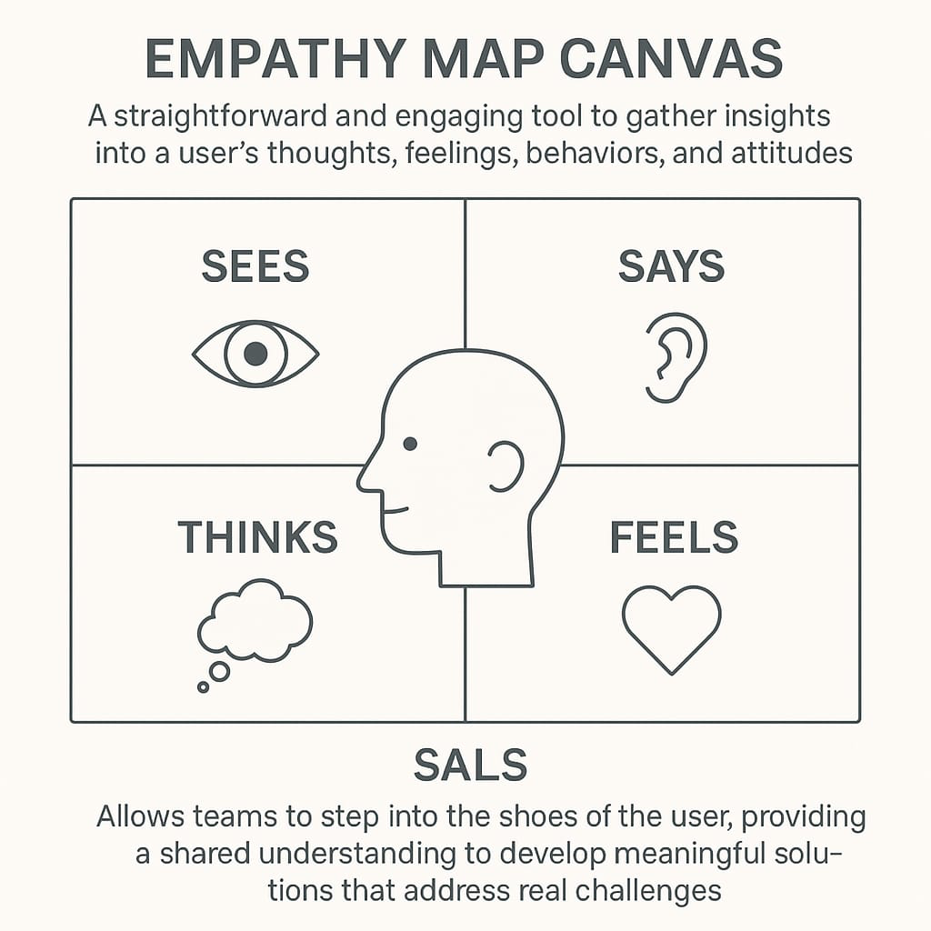

* **Example:** LearnHub
* "I need a doctor who listens and doesn't rush through the appointment.
* "Is this doctor really good, or are the reviews just curated?"
* Searches for doctor reviews across multiple sites
* Hopeful for a simpler, more transparent way to choose healthcare.